IBM ASSIGNMENT – 1

**Time table using HTML**

TIMETABLE PROGRAM

**Source code:**

<!DOCTYPE html>

<html

<head>

<title>Table</title>

<style>

body{

margin-top: 100px;

}

table,th,td{

border: 1px solid black;

border-collapse: collapse;

text-align: center;

}

</style>

</head>

<body>

<center>

<table>

<tr>

<td colspan="3"></td>

<td class="td">MLx</td>

<td class="td" colspan="4">Morning Lab for 2nd and 4th year</td>

<td></td>

<td class="td" colspan="3">Reserved Slots</td>

</tr>

<tr>

<td colspan="3"></td>

<td class="td">ALx</td>

<td class="td" colspan="4">Afternoon lab for 1st and 3rd year</td>

<td></td>

<td>Y</td>

<td colspan="2">Open Elective</td>

</tr>

<tr>

<td colspan="9"></td>

<td>X</td>

<td colspan="2">HSS Elective</td>

</tr>

<tr>

<td colspan="3"></td>

<td colspan="2">A,B,C,D,E</td>

<td colspan="4">Time Slots for 1st and 3rd Year</td>

<td colspan="3"></td>

</tr>

<tr>

<td colspan="3"></td>

<td colspan="2">A1,B1,C1,D1,E1</td>

<td colspan="4">Time Slots for 2nd and 4th year</td>

<td colspan="3"></td>

</tr>

<tr>

<td colspan="12">.</td>

</tr>

<tr>

<th>Time</th>

<th>08-08:55</th>

<th>09:09:55</th>

<th>10-10:55</th>

<th>11-11:55</th>

<th>12-12:55</th>

<th>01-02:00</th>

<th>02-02:55</th>

<th>03-03:55</th>

<th>04-04:55</th>

<th>05-05:55</th>

<th>06-06:00</th>

</tr>

<tr>

<th>Day</th>

<th>Tutorial</th>

<td></td>

<td></td>

<td></td>

<td>HS Elective</td>

<th rowspan="11">BREAK</th>

<td>Open Elective</td>

<td></td>

<td></td>

<td></td>

<th>Tutorial</th>

</tr>

<tr>

<td rowspan="2">Monday</td>

<td rowspan="2">A/A1</td>

<td>B</td>

<td>C</td>

<td>D</td>

<td rowspan="2">X</td>

<td rowspan="2">Y</td>

<td>A1</td>

<td>B1</td>

<td>C1</td>

<td rowspan="2">D/D1</td>

</tr>

<tr>

<td colspan="3">ML1</td>

<td colspan="3">AL1</td>

</tr>

<tr>

<td rowspan="2">Tuesday</td>

<td rowspan="2">E/E1</td>

<td>A</td>

<td>B</td>

<td>C</td>

<td rowspan="2">X</td>

<td rowspan="2">Y</td>

<td>E1</td>

<td>A1</td>

<td>B1</td>

<td rowspan="2">C/C1</td>

</tr>

<tr>

<td colspan="3">ML2</td>

<td colspan="3">AL2</td>

</tr>

<tr>

<td rowspan="2">Wednesday</td>

<td rowspan="2">D/D1</td>

<td>E</td>

<td>A</td>

<td>B</td>

<td rowspan="2">X</td>

<td rowspan="2">Y</td>

<td>D1</td>

<td>E1</td>

<td>A1</td>

<td rowspan="2">B/B1</td>

</tr>

<tr>

<td colspan="3">ML3</td>

<td colspan="3">AL3</td>

</tr>

<tr>

<td rowspan="2">Thursday</td>

<td rowspan="2">C/C1</td>

<td>D</td>

<td>E</td>

<td>A</td>

<td rowspan="2">X</td>

<td rowspan="2">Y</td>

<td>C1</td>

<td>D1</td>

<td>E1</td>

<td rowspan="2">A/A1</td>

</tr>

<tr>

<td colspan="3">ML4</td>

<td colspan="3">AL4</td>

</tr>

<tr>

<td rowspan="2">Friday</td>

<td rowspan="2">B/B1</td>

<td>C</td>

<td>D</td>

<td>E</td>

<td rowspan="2">X</td>

<td rowspan="2">Y</td>

<td>B1</td>

<td>C1</td>

<td>D1</td>

<td rowspan="2">E/E1</td>

</tr>

<tr>

<td colspan="3">ML5</td>

<td colspan="3">AL5</td>

</tr>

</table>

</center>

</body>

</html>

**Output Screenshot:**

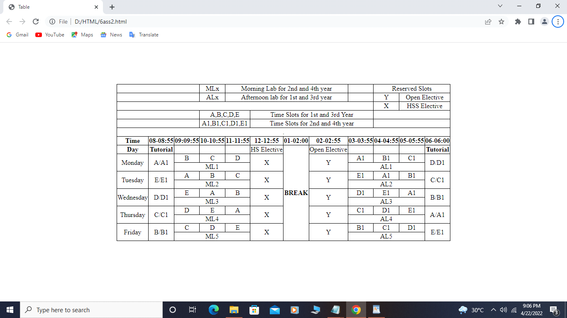

**Registration form using html, css and JavaScript**

**PROCEDURE:**

**Using form tag in html created a form** The <form> tag is used to create an HTML form for user input.

**the td tag and tr tag make the form into a perfect agranment.**

**<td>** The <td> HTML element **defines a cell of a table that contains data**. It participates in the table mode

<tr> The <tr> HTML element **defines a row of cells in a table**.

To submit this form created a submit button using onclick tag in javascript

The onclick event occurs when the user clicks on an element.

The event I have created are to submit the information of the students .

**Coding:**

<html>

<head>

<title>form</title>

<script>

function myFunction() {

var x = document.getElementById("fname").value;

var y = document.getElementById("lname").value;

var rn = document.getElementById("ronum").value;

var d = document.getElementById("dept").value;

var yr = document.getElementById("year").value;

var dob = document.getElementById("dbirth").value;

var gdr = document.getElementById("gndr").value;

var mnum = document.getElementById("num").value;

var mid = document.getElementById("mail").value;

var lknwn = document.getElementById("lang").value;

var p =0;

if(x == "" )

{

alert("Please provide your first name");

document.getElementbyId.fname.focus();

}

if(y == "")

{

alert("Please provide your last name");

document.getElementbyId.lname.focus();

}

if(rn == "")

{

alert("Please provide your roll number");

document.getElementbyId.ronum.focus();

}

if(d == "")

{

alert("Please provide your department");

document.getElementbyId.dept.focus();

}

if(mid == "")

{

alert("Please provide your email");

document.getElementbyId.mail.focus();

}

if(mnum == "")

{

alert("Please provide your mobile number");

document.getElementbyId.num.focus();

}

if(gdr == "")

{

alert("Please provide your gender");

document.getElementbyId.gndr.focus();

}

if(yr == "")

{

alert("Please provide your year of study");

document.getElementbyId.year.focus();

}

if(dob == "")

{

alert("Please provide your date of birth");

document.getElementbyId.dbirth.focus();

}

else

{

p=1;

alert ("Name :" +x+" "+y +"\nRollnumber :" +rn +"\nDepartment :"+d + "\nYear of Study : " +yr + "\nDate of Birth : "+dob + "\nGender : " +gdr + "\nMobile number :"+ mnum+ "\n mail id : " +mid);

}

if(p==1)

{

alret("Registered successfully");

}

}

</script>

</head>

<style>

body {

background-image: url("https://encrypted-tbn0.gstatic.com/images?q=tbn:ANd9GcRIT5mi3uXG1DgwRbKgsksO9oAbc2wpWXT_lw&usqp=CAU");

}

</style>

<body

style="color:slatebllue";>

<h1 ><center><font-size=40-px>Registration form</font></center></h1>

<form >

<table align="center">

<td > First name:<span style="color:red">*<span></td>

<td><input type="text" id="fname" placeholder="enter first name here" required></td>

</tr>

<tr>

<td>Last name:<span style="color:red">*<span></td>

<td ><input type="text" id="lname" placeholder="enter lastname here"required></td>

</tr>

<tr>

<td >Roll number:<span style="color:red">*<span></td>

<td><input type="text" id="ronum" placeholder="enter roll numbere here" maxlength="10" \\\required></td>

</tr>

<tr>

<td>Department:<span style="color:red">*<span></td>

<td><input type="department" id="dept" Placeholder="Enter your department here" required></td>

</tr>

<tr>

<td>Email id:<span style="color:red">*<span></td>

<td><input type="email" id="mail" placeholder="enter maid id here" required><br><br></td>

</tr>

<tr>

<td >Mobile number:<span style="color:red">*<span></td>

<td><select>

<option>91+</option>

<option>81+</option>

<option>71+</option>

<option>61+</option>

</select>

<input type="mobile number" id="num" placeholder="98********" maxlength="10" required></td>

</tr>

<tr>

<td>Gender: <span style="color:red">*<span></td>

<td><select>

<option value="male" id="gndr">male</option>

<option value="female" id="gndr">female</option>

<option value="other" id="gndr">other</option>

</select></td>

</tr>

<tr>

<td>Pursing year:<span style="color:red">*<span></td>

<td> <input type="radio" id="year" name="y1">first year

<input type="radio" id="year" name="y1">second year

<input type="radio" id="year" name="y1">third year

<input type="radio" id="year" name="y1">final year</td>

</tr>

<tr>

<td>Date of birth:<span style="color:red">*<span></td>

<td><input type="date" id="dbirth" required></td>

</tr>

<tr>

<td>Address:</td>

<td> <textarea rows = "5" cols = "50" name = "description" placeholder="Type your address here"></textarea></td>

</tr>

<tr>

<td>Languages known:</td>

<td><input type="checkbox" id="lang" name="e">

<label> english</label>

<input type="checkbox" id="lang" name="t">

<label> tamil</label>

<input type="checkbox" id="lang" name="h">

<label> hindi</label></td>

</tr>

<tr>

<td align="center" height="60">

<td><button onclick="myFunction()">SUBMIT</button></td>

</td>

</tr>

</form>

</body>

</html>

**RESULTS:**

